Project

Report

Automation Testing for Opencart

Presented by :
K V Sai Krishna
Yamuna Sri
Jhansi Lakshmi
Sritej Reddy M
Santhoshi Nikhitha
Sumanth B
Prasanna S

E-Commerce Automation Testing Capstone Project Report (OpenCart)
Introduction:
The E-commerce Automation Testing Capstone Project aims to automate the testing of critical functionalities on the OpenCart demo site. OpenCart is a widely-used open-source e-commerce platform, known for its user-friendly interface and extensive customization options. This project focuses on leveraging automated testing tools and frameworks to enhance test coverage, reduce manual testing efforts, and ensure a reliable and seamless user experience. By integrating these automated tests into a Continuous Integration/Continuous Deployment (CI/CD) pipeline, we aim to provide continuous testing, which is crucial for maintaining high-quality software.
Project Objectives:
The primary objectives of the E-commerce Automation Testing Capstone Project are:
- Automate critical functional tests for the OpenCart demo site
- Enhance test coverage and reduce manual testing effort
- Ensure the platform provides a reliable and seamless user experience
- Integrate automated tests into a CI/CD pipeline for continuous testing
Automation Tools and Development Environment
The following tools and technologies have been employed in the E-commerce Automation Testing Capstone Project:
- Automation Tools
  - Selenium: For web application testing
  - TestNG: Framework for structuring and running tests
- Development Tools
  - Java: Programming language for writing test scripts
  - Maven: Build automation tool for managing dependencies
- CI/CD Tools
  - Jenkins: For automating the testing process within the CI/CD pipeline
  - Git: For version control and managing test scripts
- Other Tools
  - BrowserStack: For cross-browser and cross-device testing to ensure compatibility
Testing Framework:
The testing framework for the E-commerce Automation Testing Capstone Project is designed using the Page Factory model, an enhanced version of the Page factorial Model. The Page Factory model simplifies the process of initializing web elements and improves the readability and maintainability of the test scripts.
- Framework Structure and Components
  - Page Classes: Representing web pages with their elements and actions using Page Factory
  - Test Classes: Containing the actual test cases using the methods from page classes
  - Utility Classes: Providing common functions like browser setup, reporting, etc.
Test Cases
The E-commerce Automation Testing Capstone Project covers the following critical test cases for the OpenCart demo site:

- User Login
Objective:
Verify that users can log in with valid credentials and that proper error messages are displayed for invalid credentials.
  - Test Steps:
    - Navigate to the OpenCart login page
    - Enter a valid email and password combination, and click "Login"
    - Verify redirection to the "My Account" page
    - Enter an invalid email and password combination, and click "Login"
    - Verify that an appropriate error message is displayed
  - Expected Results:
    - Users with valid credentials should be redirected to the "My Account" page
    - Users with invalid credentials should see an error message indicating login failure
- User Registration
Objective:
  - Verify that new users can register successfully and that all mandatory fields are validated.

  - Test Steps:
    - Navigate to the registration page
    - Enter valid information in required fields and agree to the privacy policy
    - Click "Continue"
    - Verify success message and redirection to "My Account" page
    - Attempt form submission with missing or invalid information
    - Verify appropriate error messages for invalid/missing inputs
  - Expected Results:
    - Users should be able to register successfully with valid information
    - Error messages should display for invalid/missing mandatory information
- Wishlist
Objective:
  - Verify that users can add items to the wishlist and that items persist between sessions.
  - Test Steps:
    - Log in to the site
    - Navigate to a product page and click "Add to Wishlist"
    - Verify product is added to wishlist
    - Log out and log back in
    - Navigate to wishlist page
    - Verify previously added product is still in wishlist
  - Expected Results:
    - Products in wishlist should persist across user sessions
    - Correct wishlist items should display after logging back in
- Add to Cart
Objective:
  - Verify that users can add items to the cart and that the cart updates correctly.
  - Test Steps:
    - Navigate to a product page and select any required options
    - Click "Add to Cart"
    - Verify product is added to cart
    - Navigate to cart page and verify correct product details
    - Remove product from cart
    - Verify cart updates correctly with product removed
  - Expected Results:
    - Products should add to cart correctly with accurate details
    - Cart should update properly when items are added/removed
- Checkout Process
Objective:
  - Verify users can complete checkout successfully with correct order details.
  - Test Steps:
    - Add items to cart
    - Navigate to checkout and complete required steps
    - Confirm order
    - Verify confirmation message and correct order details
    - Verify order confirmation email is sent
  - Expected Results:
    - Users should complete checkout without errors
    - Order details should capture and display accurately
    - Confirmation email should be sent to user
- Logout
Objective:
  - Verify that users can log out successfully and are redirected to homepage.
  - Test Steps:
    - Log in to site
    - Click "Logout"
    - Verify user is logged out and redirected to homepage
  - Expected Results:
    - Users should log out successfully
    - After logout, users should redirect to homepage
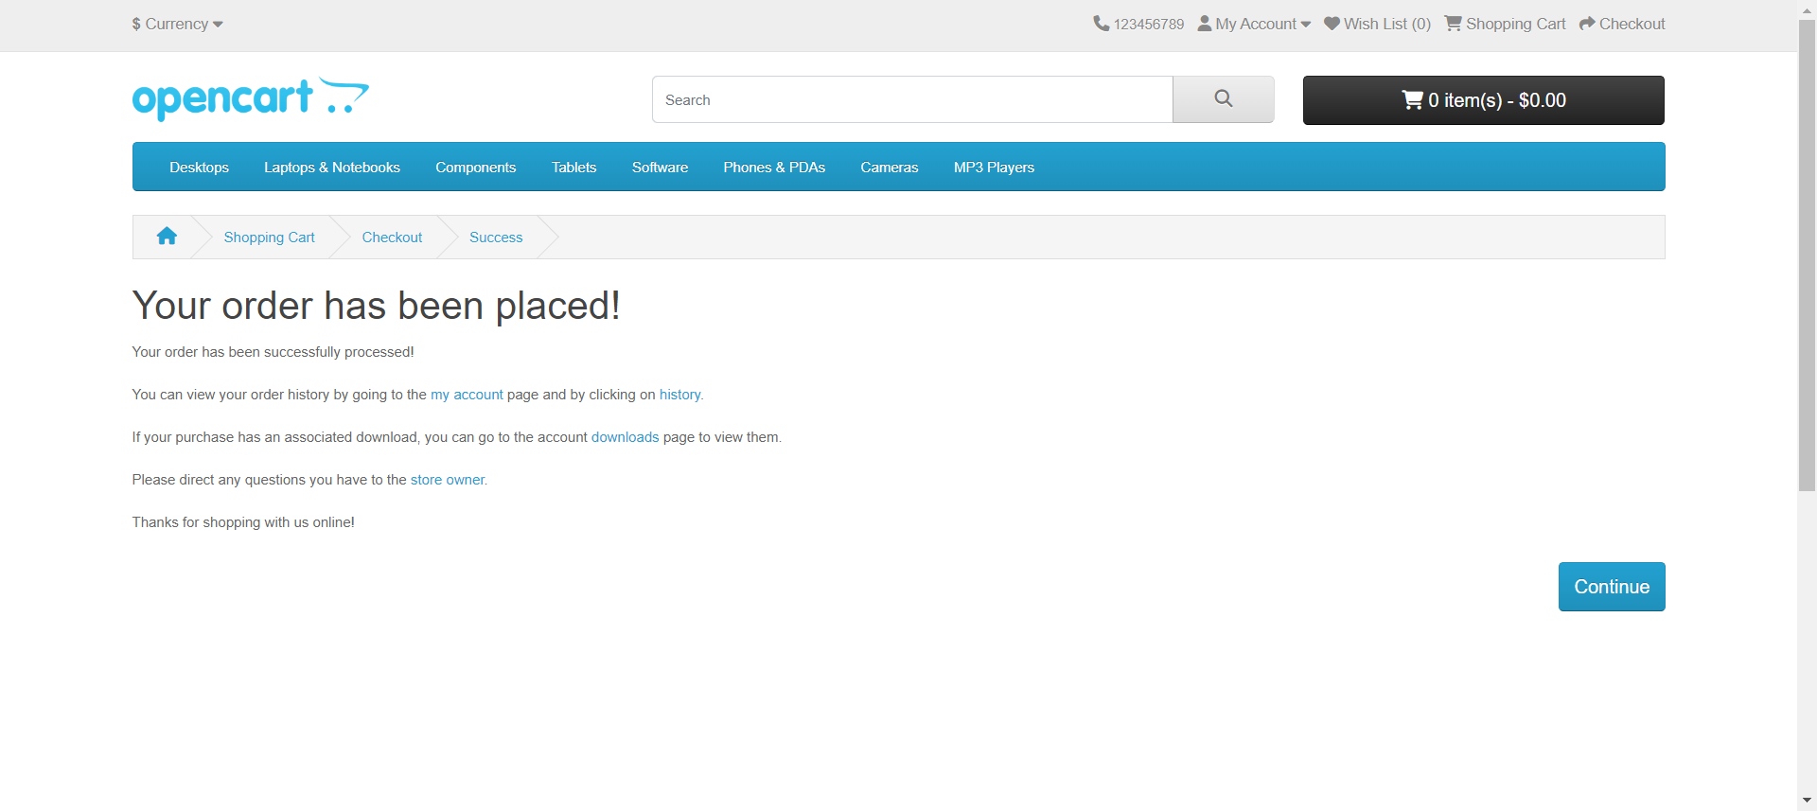
Successful Order Placement Screenshot The following screenshot showcases a successful order placement on the OpenCart demo site:
[Screenshot: Order Confirmation page showcasing a successful order placement]

Test Execution and Reporting
The automated tests are executed as part of the CI/CD pipeline, ensuring continuous testing and early detection of issues or regressions. Test execution is orchestrated by Jenkins, triggering test runs based on schedules or events like code commits. Detailed test reports are generated, providing insights into test results, passed/failed tests, error messages, and test coverage metrics.
Test Result Analysis and Issue Tracking
Test reports are analyzed to identify failures or issues. Any failures undergo root cause analysis by reviewing error logs and screenshots. Identified issues are tracked and managed using an issue tracking system like JIRA or GitHub Issues. Issues are prioritized based on severity and impact, then assigned to development team members for resolution.
Continuous Integration and Deployment
The automated tests integrate into the CI/CD pipeline, enabling continuous testing and deployment:
- Build and Compile: Project is built and compiled using Maven
- Unit Testing: Automated unit tests execute to verify code units
- Integration Testing: Automated integration tests run, including from this project
- Code Analysis: Static analysis tools check codebase for issues
- Test Reporting: Detailed reports capture unit, integration, and end-to-end test results
- Deployment: If all prior steps pass, application deploys to target environment
Cross-Browser and Cross-Device Testing
To ensure compatibility across browsers and devices, BrowserStack enables cross-browser and cross-device testing of the automated tests on various browser/device combinations. This identifies and resolves compatibility issues early.
Test Maintenance and Scalability
The Page factorial Model design pattern separates test code from page implementation details, improving maintainability as the application evolves. The modular approach allows extending the framework by creating new page classes and updating test classes when new features arise.
Collaboration and Version Control
Test scripts, framework components, and files are stored in a Git repository, enabling collaboration and version control. Changes are tracked, reviewed, and merged systematically to reduce conflicts and ensure traceability.

Conclusion
The E-commerce Automation Testing Capstone Project provides a robust testing framework for automating OpenCart's critical tests. Leveraging Selenium, TestNG, Java, Maven, Jenkins, Git, and BrowserStack, it enhances coverage, reduces manual effort, and ensures reliable user experiences. Continuous testing via CI/CD integration allows early issue detection and faster feedback. Detailed reporting, issue tracking, maintainability, scalability, and cross-platform testing ensure the framework adapts to evolving needs while streamlining the testing process. Overall, it demonstrates automated testing's value in ensuring e-commerce platform quality and reliability.

